Snowflake Stage Options

Table of Contents
Introduction to Snowflake 2
Snowflake Architecture 2
Connecting to Snowflake 3
Snowflake External Stage (S3) with Public Access 3
Creating External Stage with S3 bucket: 3
Loading the data in Snowflake table using the External Stage created above: 5
Snowflake External Stage (S3) with No Public Access 7
Configure Access Permissions for the S3 Bucket 8
Create a IAM Policy: 8
Create the IAM Role in AWS 8
Create a Cloud Storage Integration in Snowflake 9
Retrieve the AWS IAM User for your Snowflake Account 10
Grant the IAM User Permissions to Access Bucket Objects 11
Create an External Stage 11
Loading your data from S3 12

Introduction to Snowflake

Snowflake’s Data Cloud is powered by an advanced data platform provided as Software-as-a-Service (SaaS). Snowflake enables data storage, processing, and analytic solutions that are faster, easier to use, and far more flexible than traditional offerings.
The Snowflake data platform is not built on any existing database technology or “big data” software platforms such as Hadoop. Instead, Snowflake combines a completely new SQL query engine with an innovative architecture natively designed for the cloud. To the user, Snowflake provides all of the functionality of an enterprise analytic database, along with many additional special features and unique capabilities.

Snowflake Architecture

Snowflake’s architecture is a hybrid of traditional shared-disk and shared-nothing database architectures. Similar to shared-disk architectures, Snowflake uses a central data repository for persisted data that is accessible from all compute nodes in the platform. But similar to shared-nothing architectures, Snowflake processes queries using MPP (massively parallel processing) compute clusters where each node in the cluster stores a portion of the entire data set locally. This approach offers the data management simplicity of a shared-disk architecture, but with the performance and scale-out benefits of a shared-nothing architecture.

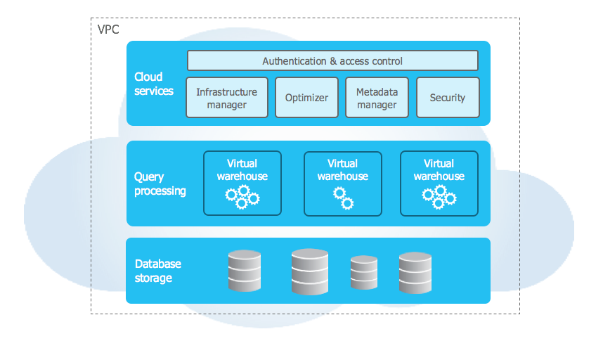

Connecting to Snowflake

Snowflake supports multiple ways of connecting to the service:
- A web-based user interface from which all aspects of managing and using Snowflake can be accessed.
- Command line clients (e.g. SnowSQL) which can also access all aspects of managing and using Snowflake.
- ODBC and JDBC drivers that can be used by other applications (e.g. Tableau) to connect to Snowflake.
- Native connectors (e.g. Python, Spark) that can be used to develop applications for connecting to Snowflake.
- Third-party connectors that can be used to connect applications such as ETL tools (e.g. Informatica) and BI tools (e.g. ThoughtSpot) to Snowflake.

Snowflake External Stage (S3) with Public Access

Creating External Stage with S3 bucket:

- Created a S3 bucket in our PoC account in Ohio (US-East-2) region & uploaded a sample file into it. The bucket has "Public Access"
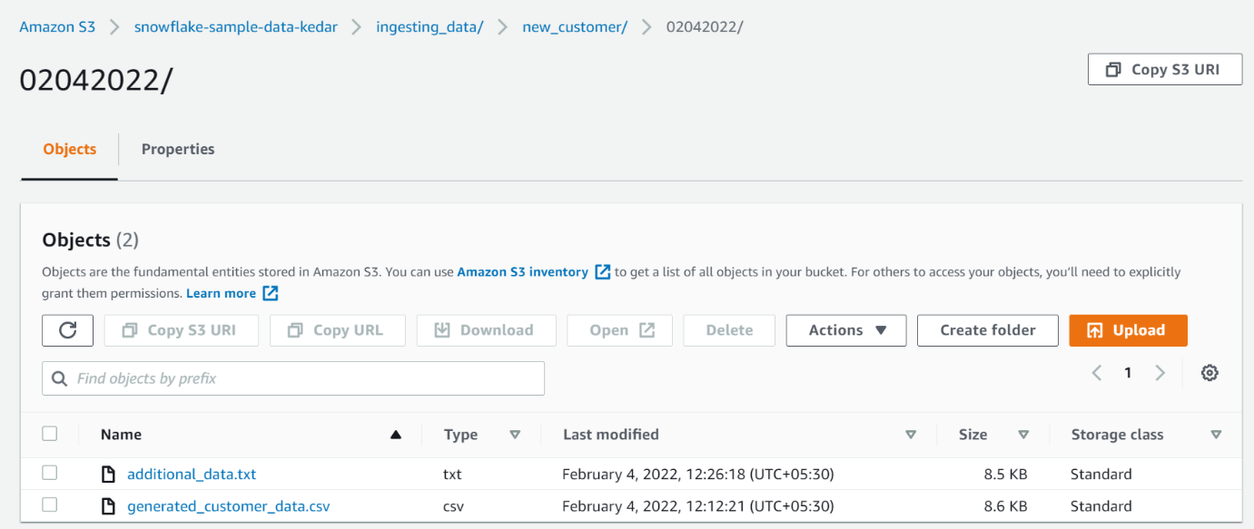

- Created a database & a table in it to upload the data into.
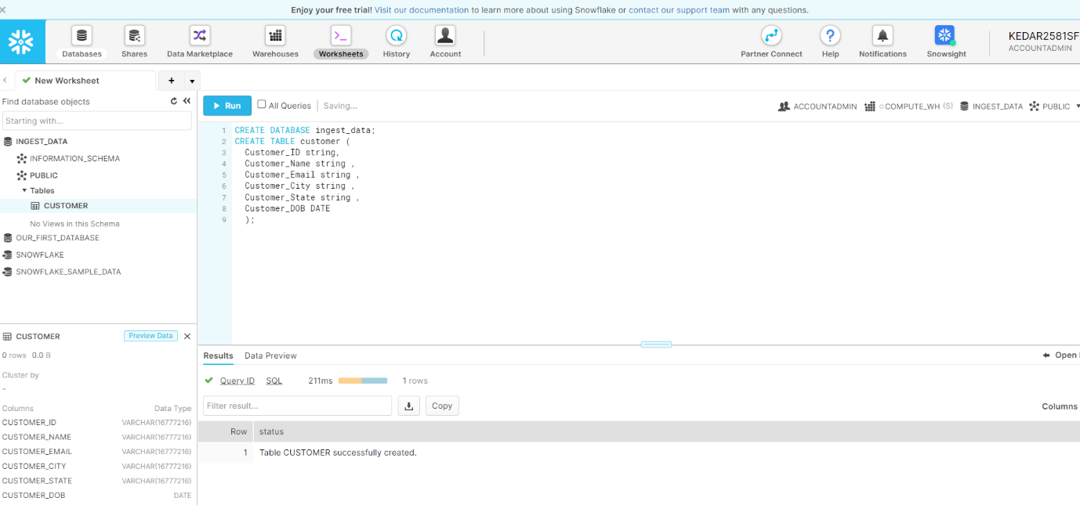

- Created an external stage using the S3 bucket that we created in the step 1
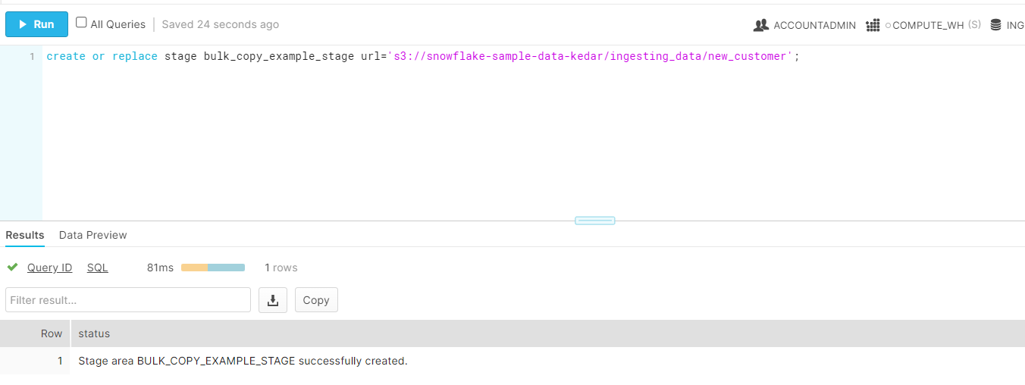

- List the files in the bucket.
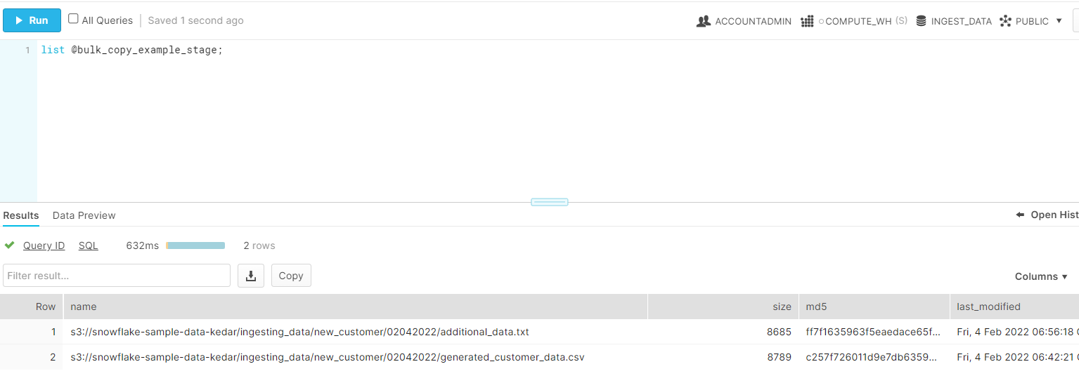

####################### Till this point the data is not loaded into the Snowflake Table that we created in Step 2 ################################

Loading the data in Snowflake table using the External Stage created above:
- Make sure we are in correct database.
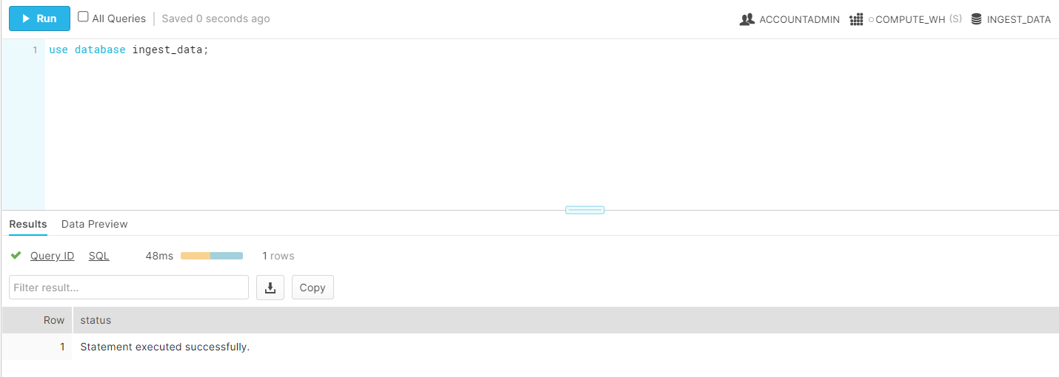

- Run "Copy" command to load the data to Snowflake table from external stage.
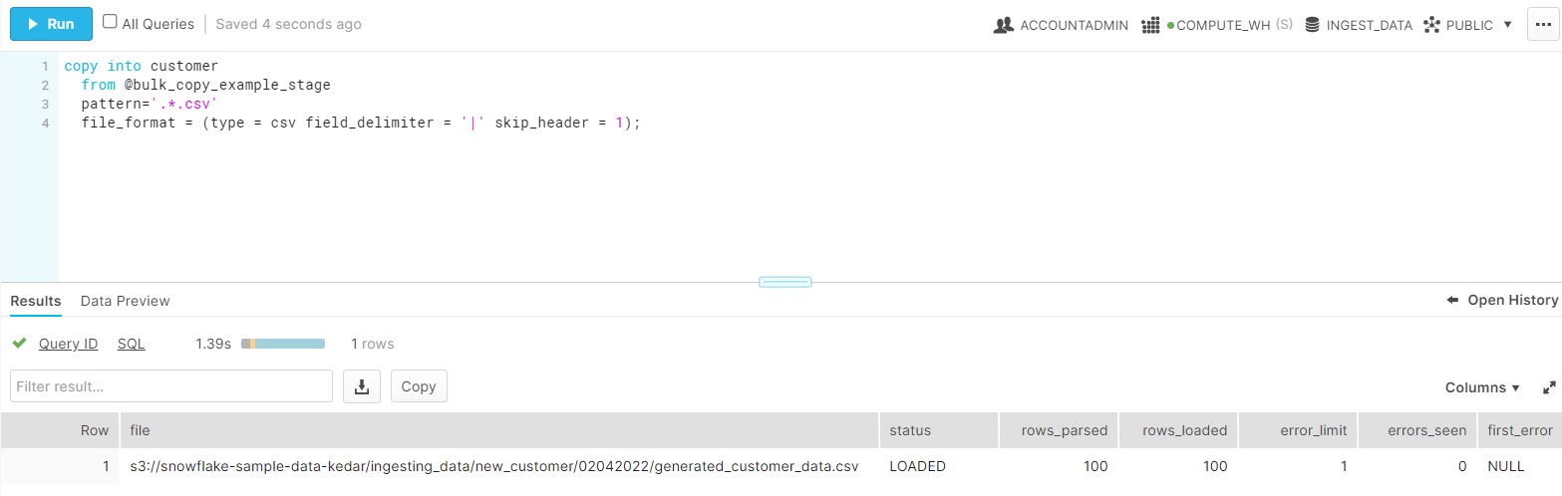

- Load the additional data from second file (.txt) in the S3 stage.
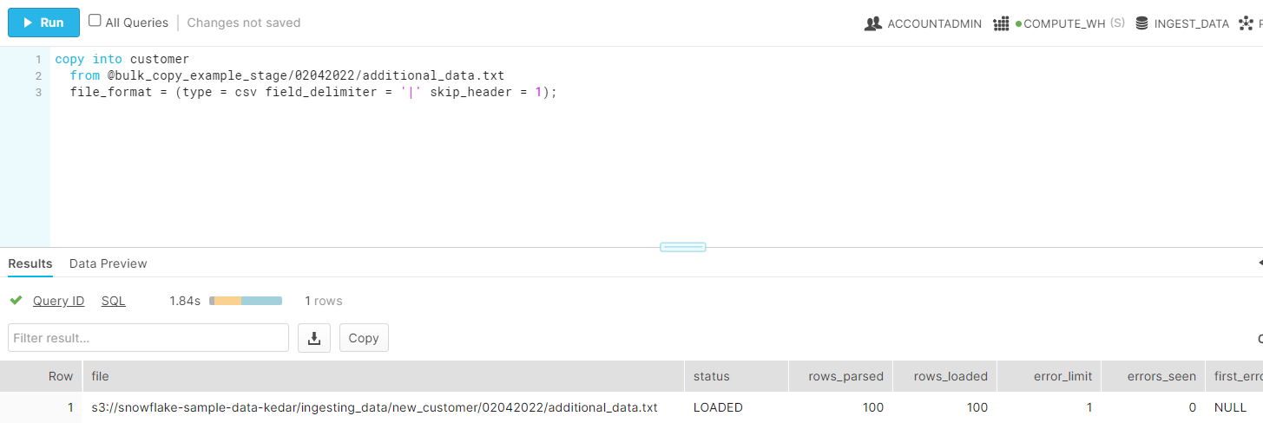

- Verify the total data is increased from 100 to 200 now.
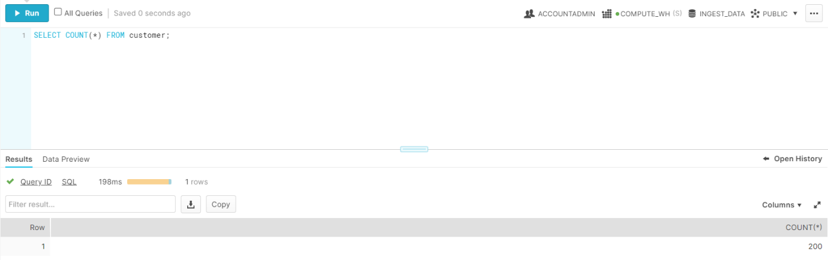

- Snowflake maintains the metadata, so if you try to upload the same data again, it doesn't upload.
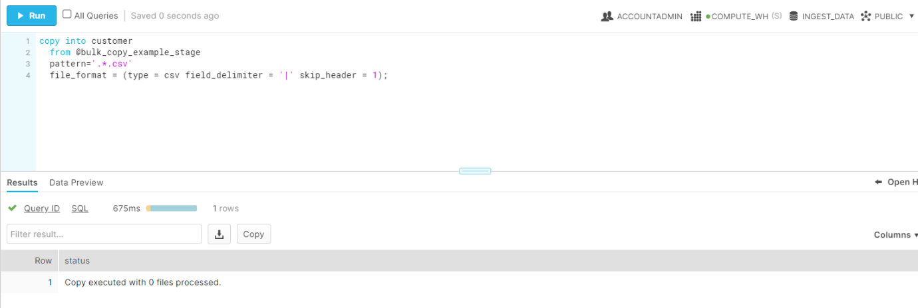

Snowflake External Stage (S3) with No Public Access

There are 3 options to configure secure access to Amazon S3
- Option 1: Configuring a Snowflake Storage Integration to Access Amazon S3 - Recommended
- Option 2: Configuring an AWS IAM Role to Access Amazon S3 — Deprecated
- Option 3: Configuring AWS IAM User Credentials to Access Amazon S3

The following diagram shows the integration flow for a S3 stage:

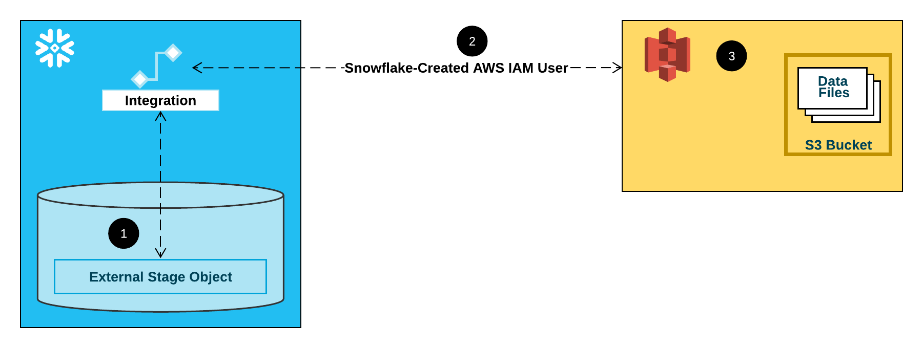

- An external (i.e. S3) stage references a storage integration object in its definition.
- Snowflake automatically associates the storage integration with a S3 IAM user created for your account. Snowflake creates a single IAM user that is referenced by all S3 storage integrations in your Snowflake account.
- An AWS administrator in your organization grants permissions to the IAM user to access the bucket referenced in the stage definition. Note that many external stage objects can reference different buckets and paths and use the same storage integration for authentication.
When a user loads or unloads data from or to a stage, Snowflake verifies the permissions granted to the IAM user on the bucket before allowing or denying access.

Configure Access Permissions for the S3 Bucket

Snowflake requires the following permissions on an S3 bucket and folder to be able to access files in the folder (and sub-folders):
- s3:GetBucketLocation
- s3:GetObject
- s3:GetObjectVersion
- s3:ListBucket
The following additional permissions are required to perform additional SQL actions:
- s3:PutObject Unload files to the bucket.
- s3:DeleteObject Either automatically purge files from the stage after a
successful load or execute REMOVE statements to
manually remove files.
As a best practice, Snowflake recommends creating an IAM policy for Snowflake access to the S3 bucket. You can then attach the policy to the role and use the security credentials generated by AWS for the role to access files in the bucket.

Create a IAM Policy:

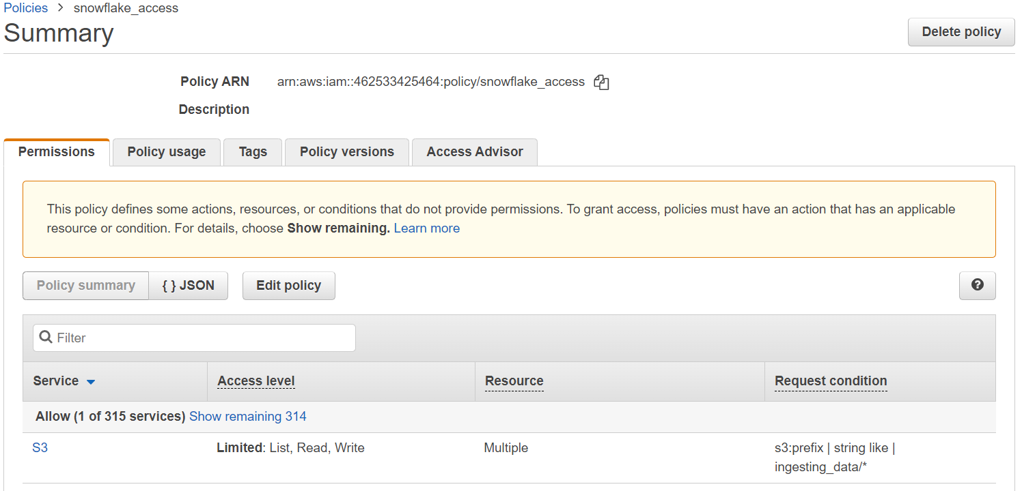

Create the IAM Role in AWS

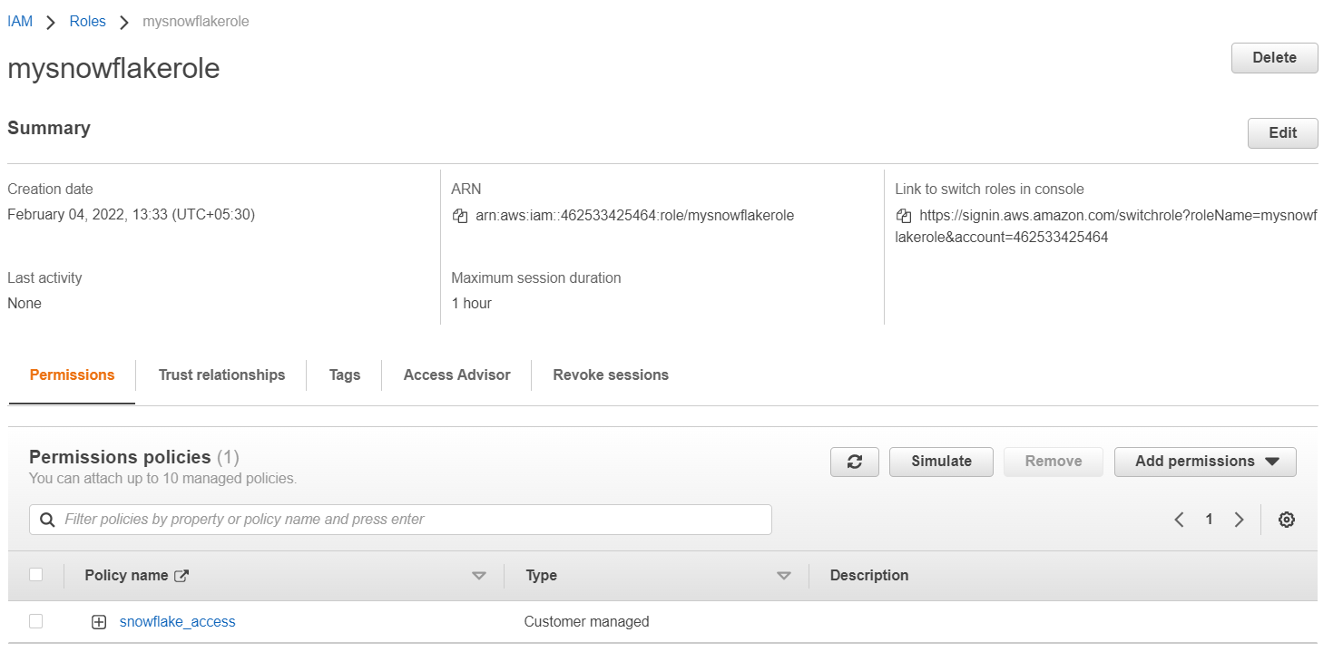

Create a Cloud Storage Integration in Snowflake

Create a storage integration using the CREATE STORAGE INTEGRATION command. A storage integration is a Snowflake object that stores a generated identity and access management (IAM) user for your S3 cloud storage, along with an optional set of allowed or blocked storage locations (i.e. buckets). Cloud provider administrators in your organization grant permissions on the storage locations to the generated user. This option allows users to avoid supplying credentials when creating stages or loading data.
A single storage integration can support multiple external (i.e. S3) stages. The URL in the stage definition must align with the S3 buckets (and optional paths) specified for the STORAGE_ALLOWED_LOCATIONS parameter.
Note: Only account administrators (users with the ACCOUNTADMIN role) or a role with the global CREATE INTEGRATION privilege can execute this SQL command.

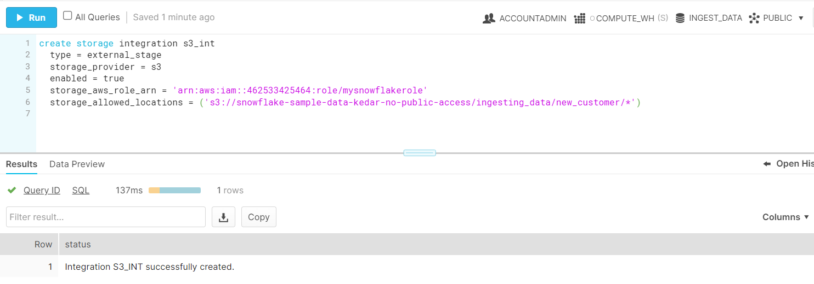

Retrieve the AWS IAM User for your Snowflake Account

- Execute the DESCRIBE INTEGRATION command to retrieve the ARN for the AWS IAM user that was created automatically for your Snowflake account:

DESC INTEGRATION <integration_name>;

Where <integration_name> is the name of the integration created in previous step.

- Record the following values.
STORAGE_AWS_IAM_USER_ARN
The AWS IAM user created for your Snowflake account, Snowflake provision a single IAM user for your entire Snowflake account. All S3 storage integrations use that IAM user.

STORAGE_AWS_EXTERNAL_ID
The external ID that is needed to establish a trust relationship.

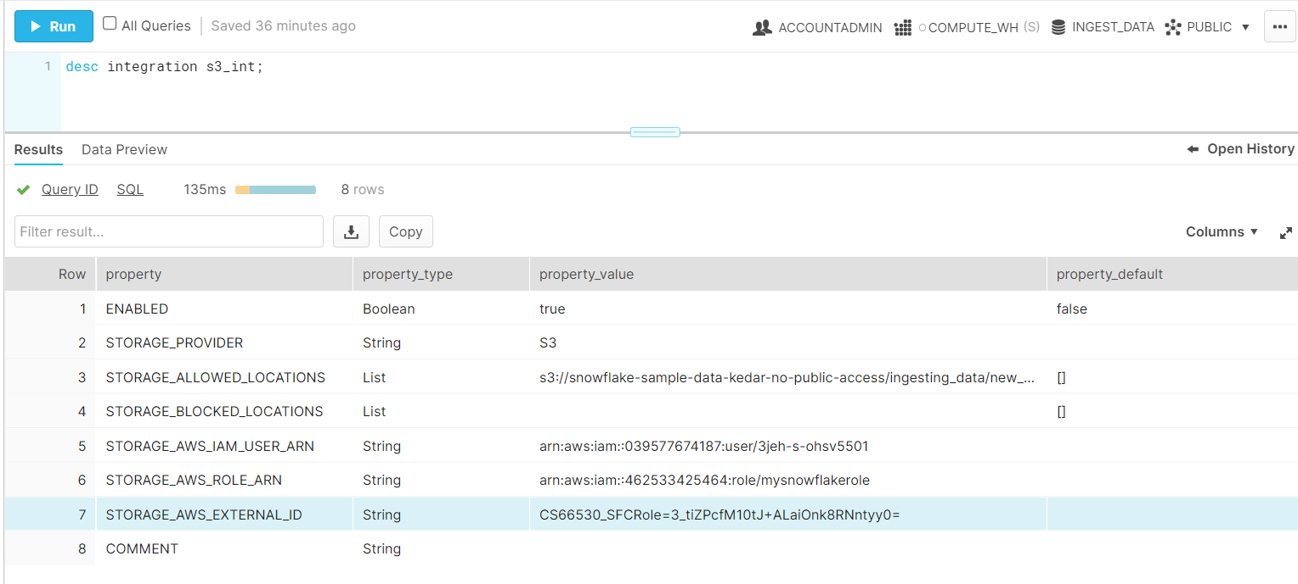

Grant the IAM User Permissions to Access Bucket Objects

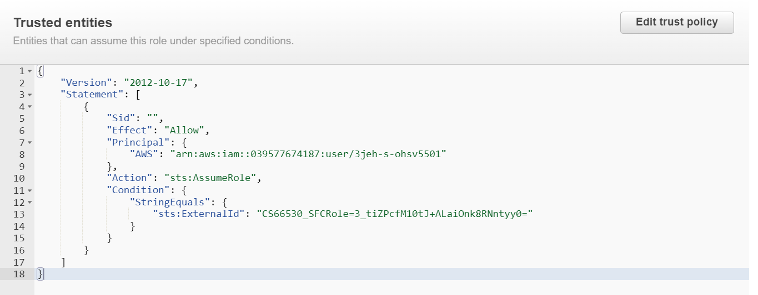

Create an External Stage

Create an external (i.e. S3) stage that references the storage integration you created in previous steps.
Note: Creating a stage that uses a storage integration requires a role that has the CREATE STAGE privilege for the schema as well as the USAGE privilege on the storage integration.
grant create stage on schema public to role ACCOUNTADMIN;

grant usage on integration s3_int to role ACCOUNTADMIN;

Create a Staged File Format

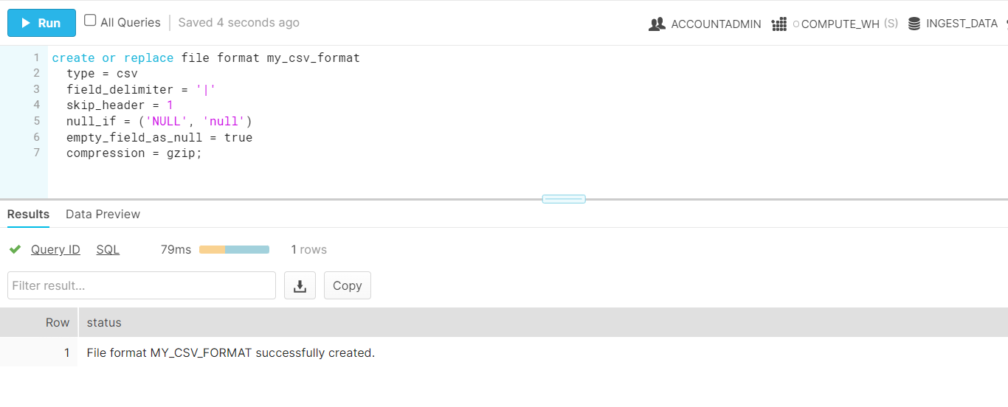
Using this file format create an External Stage
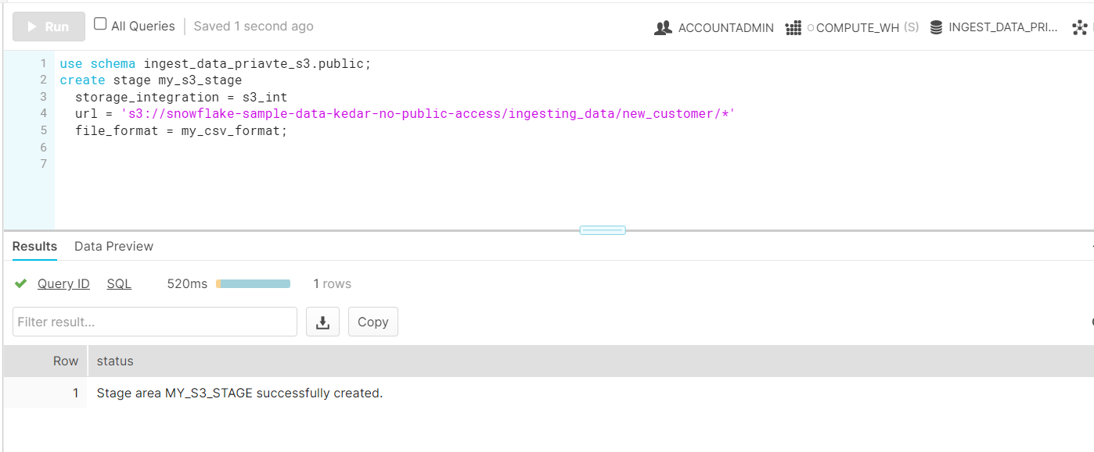

Loading your data from S3

Note: Loading data requires a warehouse. If you are using a warehouse that is not configured to auto resume, execute ALTER WAREHOUSE to resume the warehouse. Note that starting the warehouse could take up to five minutes.
copy into customer_private_s3
from @my_s3_stage
file_format = my_csv_format;

